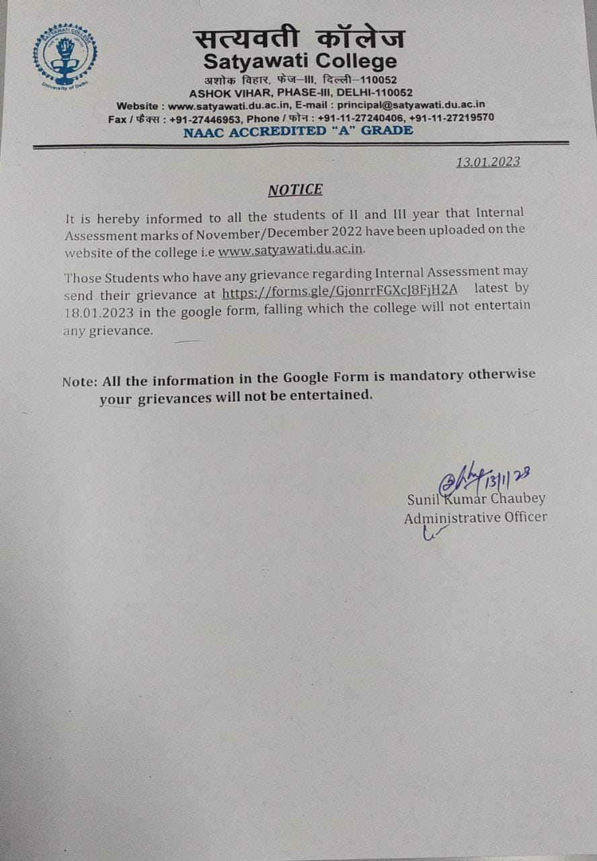

LINK : https://forms.gle/GjonrrFGXcJ8FjH2A

